Google Finance Stock Market Dashboard

Project Overview
The Google Finance Stock Market Dashboard is an interactive Power BI report built using real-time stock market data. It provides a visual summary of major global indices and company performance, helping users understand market trends at a glance.
Purpose of the Project
To track and analyze stock price movements, index performance, and percentage contributions using real-time or near real-time Google Finance data, enabling faster financial insights and decision-making.

Key Features of the Dashboard

1️. Company Filter
- Allows users to select any company or index.
- Updates all visuals dynamically.

2️. Market Summary KPIs
- Sum of Amount
- Average of Amount
- Sum of Percentage
- Current Index Value (BSE SENSEX shown in sample)

3️. Sum of Amount by Percentage (Bar Chart)
- Compares different stock indices and company values.
- Highlights highest and lowest contributors.

4️. Line Chart – Stock Trend
- Shows fluctuations in stock amount over time.
- Provides quick insight into market volatility.

5️. Pie Chart – Percentage Share by Company
- Displays how much each company contributes to the selected index.

6️. Company List Table
- Shows individual company values with indicators (up/down arrows).
Benefits
- Provides a consolidated real-time view of global and Indian stock markets.
- Helps users compare multiple indices and company performances easily.
- Suitable for investors, analysts, students, and financial learners.
- Simplifies decision-making with clean KPIs and visual insights.

Conclusion
The Google Finance Stock Market Dashboard provides a clear and real-time view of market performance by combining index values, company-wise contributions, and trend visuals in one place. It helps users quickly understand market movements, compare stocks, and make informed financial decisions with ease

Dataset Link : https://www.google.com/finance/?hl=en
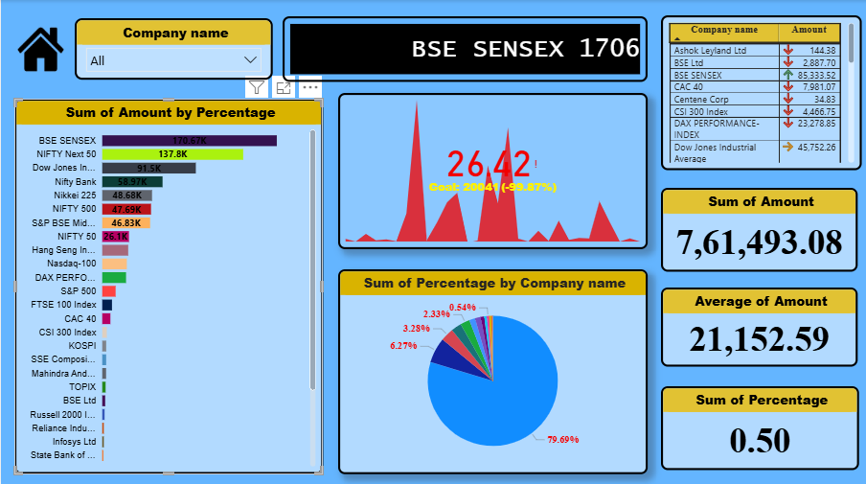
Over view:

